Dissemination activity- Report

Title: Raising awareness on cybersecurity among students

Organizing institution: Science and Technology Park Montenegro

Venue: Science and Technology Park Montenegro

Date: 28.03.2025.

Type: Education and training events

Target groups:

☐ Industry, business partners | ☐ Innovators | ☐ EU Institutions
☐ National authorities | ☐ Regional authorities | ☐ Local authorities
☐ Civil society | ☒ Citizens | ☐ Research communities
☒ Specific end user communities | ☐ International organisation  (UN body, OECD, etc.) | ☐ Investors
 | ☐ Other

Short description:

As part of the CSupMNE project, students from the Faculty of Economics visited the Science and Technology Park, where we presented our institute’s work and introduced them to key cybersecurity concepts at the HEI level.

Link (if applicable)

n/a

Description:

As part of the CSupMNE project, we welcomed students from the Faculty of Economics to the Science and Technology Park, where they had the opportunity to learn more about our institute’s activities and explore the importance of cybersecurity at the higher education level (HEIs).

During the session, we provided an informal introduction to our work, highlighting our involvement in digital transformation, innovation, and capacity-building initiatives. We then introduced students to the basics of cybersecurity, discussing key challenges that universities and businesses face, such as cyber threats, data protection, and digital security practices.

The session was interactive, encouraging students to share their perspectives on cybersecurity risks in their daily lives and future careers. We also addressed practical cybersecurity measures, such as safe internet usage, password management, and recognizing phishing attempts.

Agenda
n/a

Photos
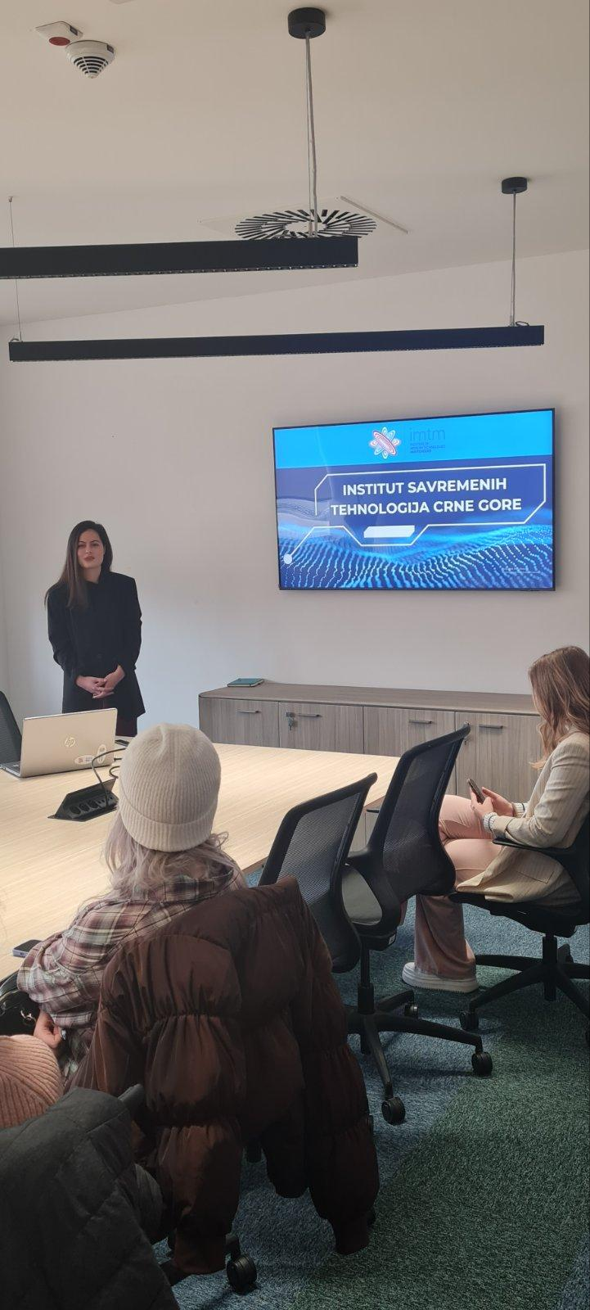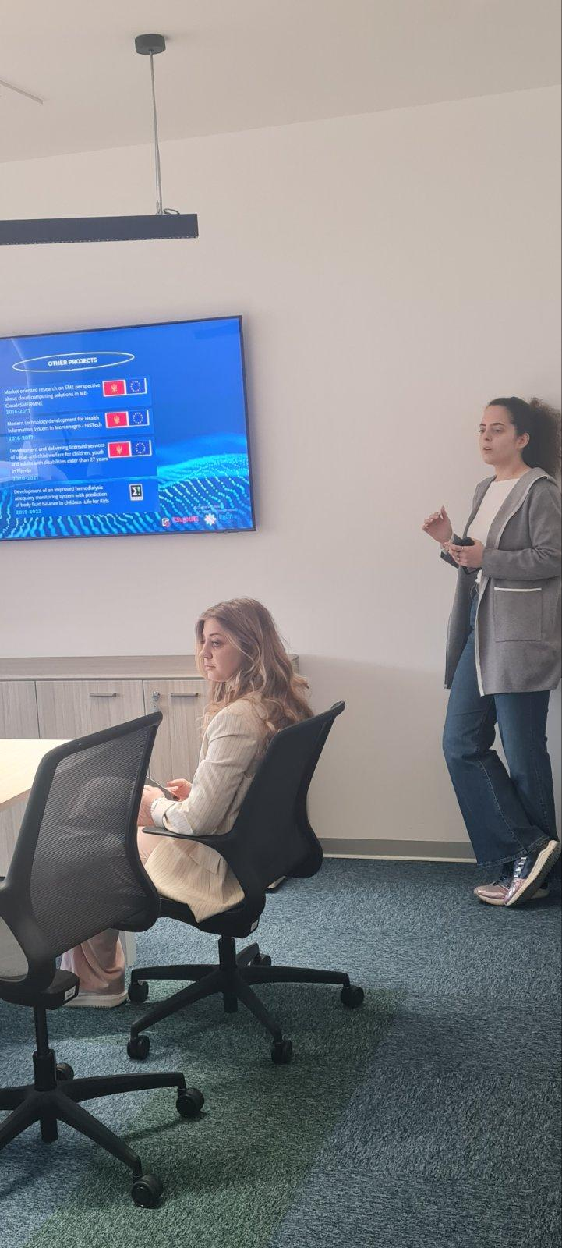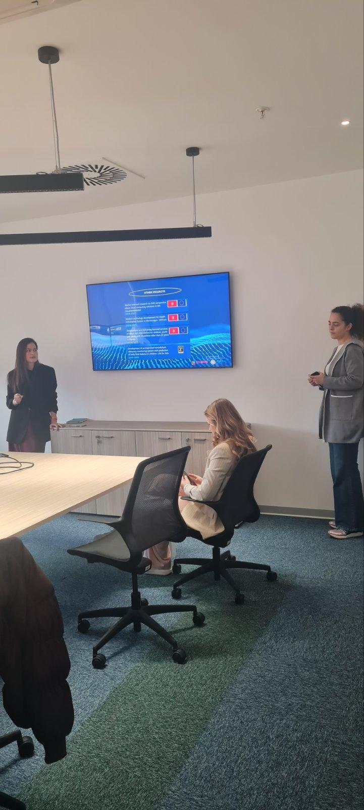

Report prepared by: Milena Ljutica

