Dissemination activity - Report

Title: ELECTRIC MOBILITY FOR THE GREEN AGENDA OF THE WESTERN BALKANS - TRENDS AND CHALLENGES OF SUSTAINABLE TRANSPORT

Organizing institution: The Engineering Academy of Serbia

Venue: The Engineering Academy of Serbia, Kneza Miloša 9/III, Belgrade, Serbia

Date: 9.5.2025

Type: Conferences

Target groups:

☒ Industry, business partners | ☐ Innovators | ☐ EU Institutions
☒ National authorities | ☒ Regional authorities | ☒ Local authorities
☒ Civil society | ☒ Citizens | ☒ Research communities
☒ Specific end user communities | ☐ International organisation  (UN body, OECD, etc.) | ☐ Investors
 | ☐ Other

Short description:

CSupMNE was presented by Professor Oliver Popović. He presented the paper “Social analysis of acceptability for autonomous
vehicles in the Republic of Serbia” and used the opportunity to discuss the project's influence on Cyber security in Western Balkans region.

Link (if applicable)

https://ias.org.rs/vesti.php#160

Description:

The Engineering Academy of Serbia, in cooperation with the Association of Engineers and Technicians of Serbia, and in accordance with the goals of the Green Agenda for the Western Balkans, organized an international conference on May 9, 2025 on the topic: "ELECTRIC MOBILITY FOR THE GREEN AGENDA OF THE WESTERN BALKANS - TRENDS AND CHALLENGES OF SUSTAINABLE TRANSPORT". Professors of the Faculty of Transport, Communications and Logistics, Prof. Emeritus Dr. Nataša Gospić and Assoc. Prof. Dr. Oliver Popović presented the objectives of the CSupMNE project to the conference participants, where they pointed out the need to implement sustainable systemic improvements and modernization of the higher education system of Montenegro with the aim of enabling the assessment, protection and management of increasing business risks and cyber threats that threatened Montenegrin higher education institutions in the digital world, and thus help ensure the protection of their staff, students and partners.

Photos
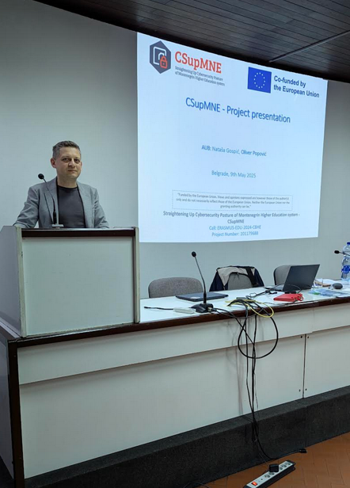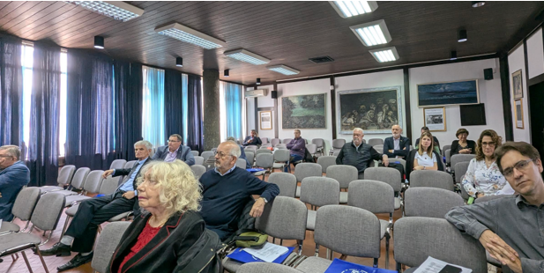
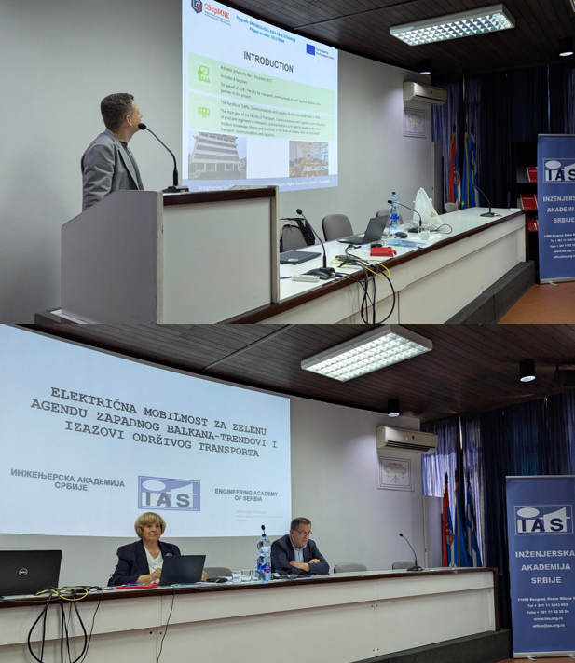

Report prepared by: Assistant prof. dr Oliver Popović

