Dissemination activity - Report

Title: Symposium - Sustainable mobility in Western Balkans

Organizing institution: Faculty for traffic, communication and logistics Budva

Venue: Akademija znanja, Žrtava fašizma 56, Budva, Montenegro

Date: 3.6.2025.

Type: Collaboration with EU-funded projects

Target groups:

☒ Industry, business partners | ☐ Innovators | ☐ EU Institutions
☒ National authorities | ☒ Regional authorities | ☒ Local authorities
☒ Civil society | ☒ Citizens | ☒ Research communities
☒ Specific end user communities | ☐ International organisation  (UN body, OECD, etc.) | ☐ Investors
 | ☐ Other

Short description:

CSupMNE was presented by Professor Nataša Gospić. She presented the scope of the project, partners in the project and project's influence on Cybersecurity in Western Balkans region.

Link (if applicable)

N/A

Description:

The Faculty of Traffic, Communications and Logistics Budva organized an international symposium on sustainable mobility in the Western Balkans. The symposium is part of the Erasmus+ project INTEC and represents an additional effort towards promoting sustainable and green transport in the Western Balkans. The presentation of the CSupMNE project was held by Prof. emeritus dr Natasa Gospic. She presented the main objectives of the project, project partners and work packages that are part of the project. The symposium was attended by more than 100 people from the country and abroad, with coverage by regional TV Budva. The dissemination of the project was attended by the coordinators of the CSupMNE project from UDG, as well as representatives of partners from the University of the Mediteran.

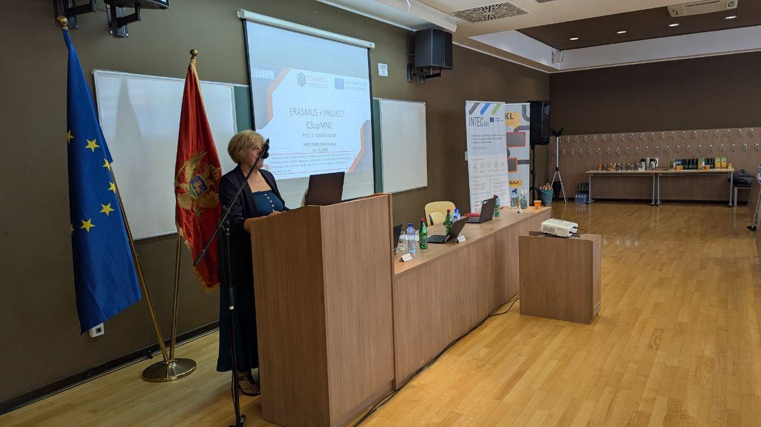
Photos

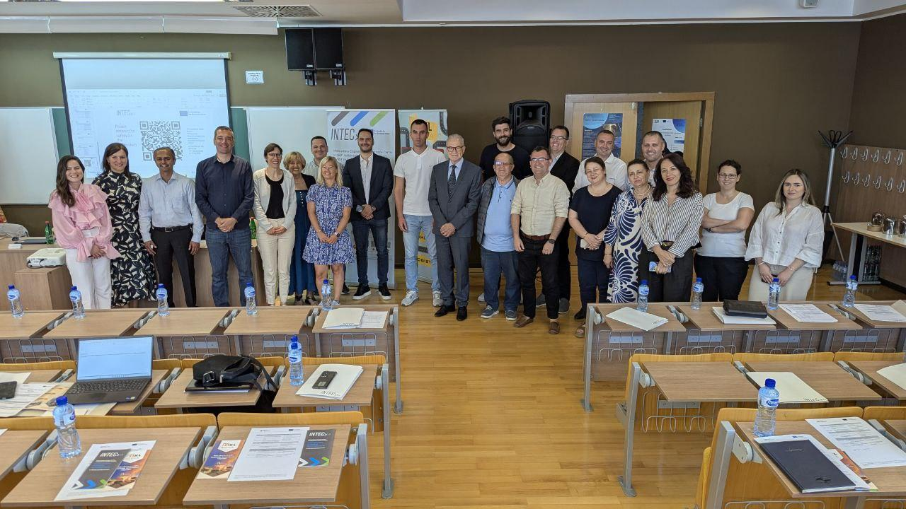
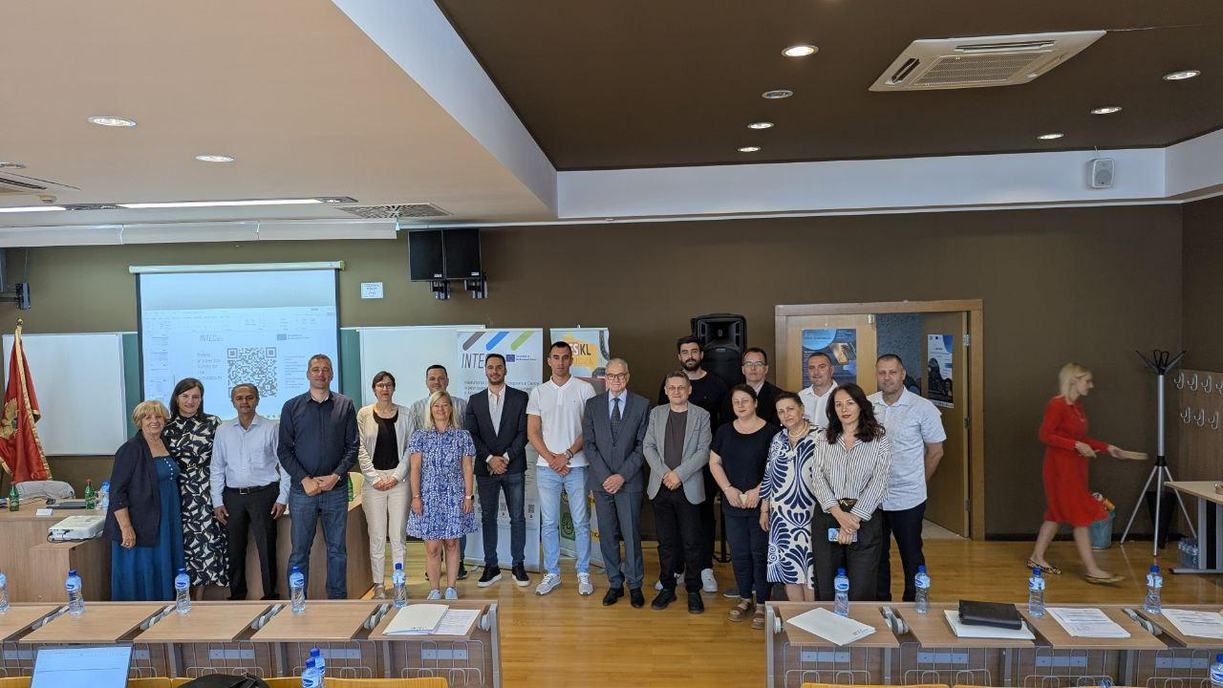

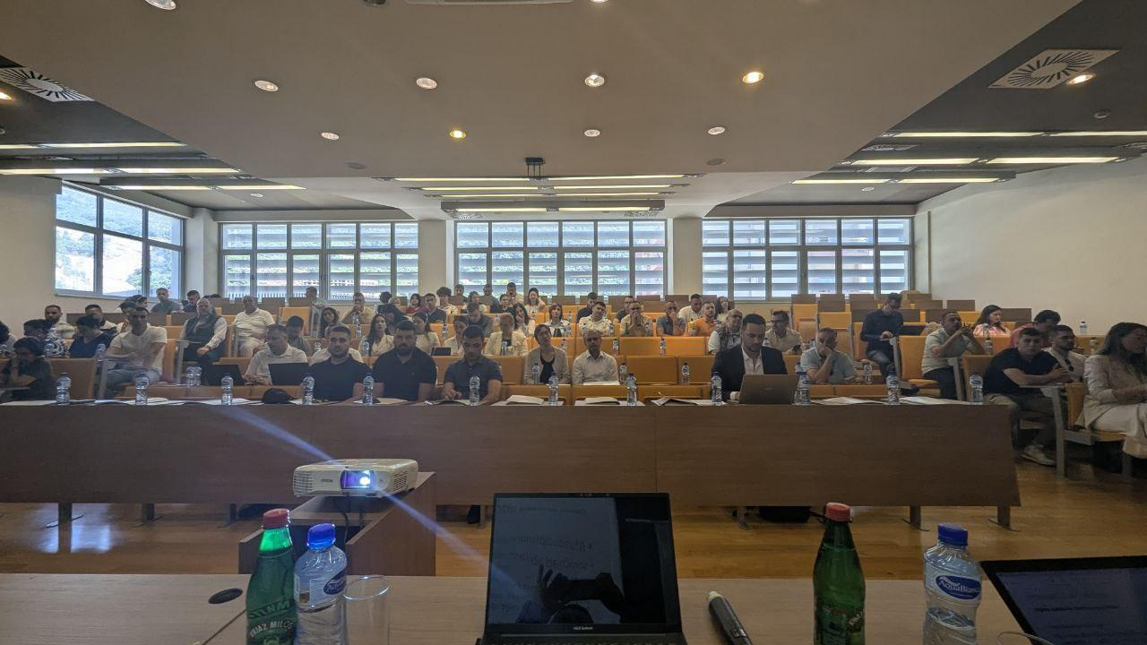

Report prepared by: Assistant prof. dr Oliver Popović

