Dissemination activity- Report

Title: Dissemination Activity of AUB within the CSupMNE Project – Participation in the MontEDIH Info Day
Organizing institution: Chamber of Economy of Montenegro, Podgorica

Venue: Chamber of Economy of Montenegro, Podgorica, Montenegro

Date: 24.06.2025

Type: Collaboration with EU-funded projects

Target groups:

☒ Industry, business partners | ☐ Innovators | ☐ EU Institutions
☒ National authorities | ☒ Regional authorities | ☒ Local authorities
☒ Civil society | ☒ Citizens | ☒ Research communities
☒ Specific end user communities | ☐ International organisation  (UN body, OECD, etc.) | ☐ Investors
 | ☐ Other

Short description:

AUB activities in CSupMNE project was presented by MSc Ivana Buzdovan.

Link (if applicable)

https://www.instagram.com/p/DLR8-N_ifTi/?igsh=MW8wOHZhcnVueDB0dg==

Description:

As part of its ongoing dissemination efforts for the CSupMNE project, the Adriatik University Bar actively participated in the Info Day and official presentation of the MontEDIH project, held on June 24, 2025, at the Chamber of Economy of Montenegro in Podgorica.
MontEDIH – the Montenegrin European Digital Innovation Hub – is a four-year project supported by the Digital Europe Programme and co-financed by the Government of Montenegro. It aims to accelerate the digital and green transformation of the Montenegrin economy and society through close collaboration between the business, research, and public sectors.
During the event, representatives of key institutions and members of the MontEDIH consortium presented an extensive range of services available to small and medium-sized enterprises (SMEs) and public sector entities in Montenegro.
The participation of AUB and other CSupMNE representatives in this event served as a valuable opportunity to share insights from the CSupMNE project and strengthen inter-project cooperation in the field of digital innovation and sustainability. This activity contributed to the visibility and dissemination of CSupMNE’s objectives, results, and future initiatives, while also exploring synergies with ongoing digital transformation efforts in the Western Balkans region.

Photos

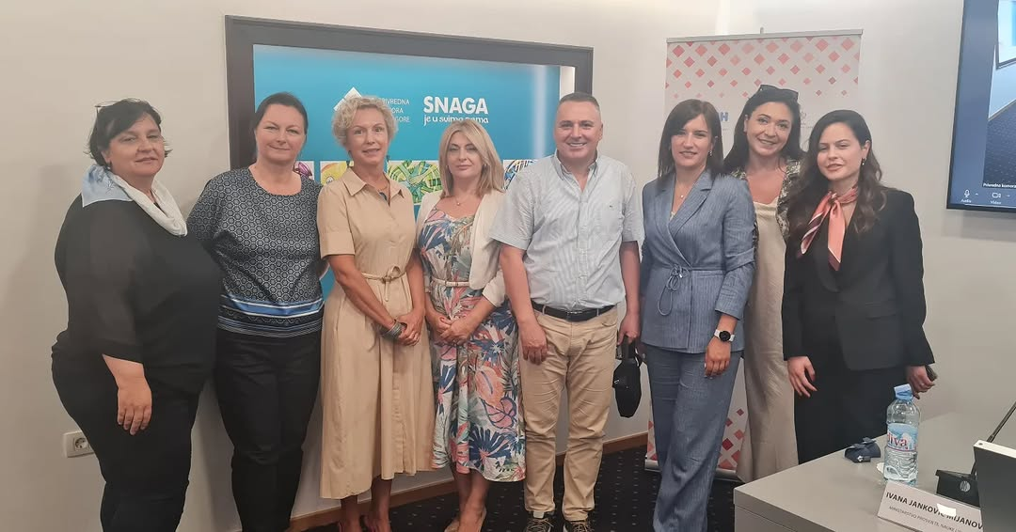

Report prepared by: Assistant prof. dr Oliver Popović

